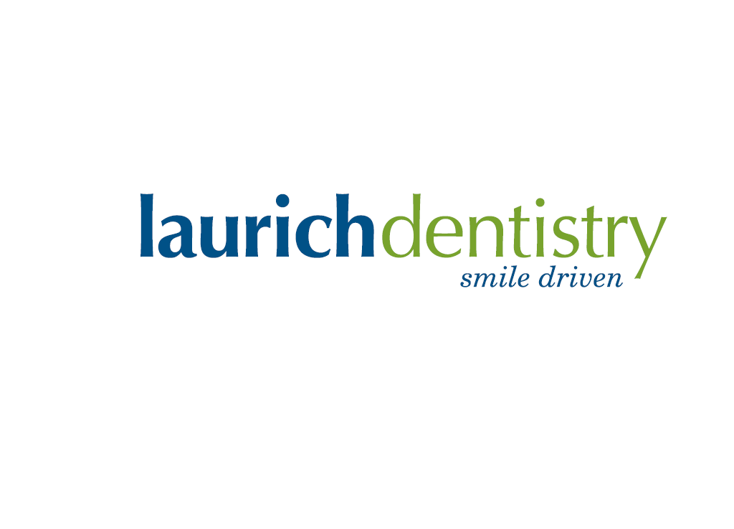
PATIENT INFORMATION: Today’s Date:__________________

Patient Name (First ,Last) ________________________________________________________

Address: ______________________________________________________________________

City – State – Zip _______________________________________________________________

Date of Birth:______________________ Email:_______________________________________

Home #: _______________________________ Cell #: _________________________________

Parents Name : _________________________________________________________________

---------------------------------------------------------------------------------------------------------------------

TREATMENT AUTHORIZATION

I ___________________________, hereby authorize and request the performance of Dental Services for my son/daughter. I also give my consent to any advisable and necessary Dental procedures; scope of intended treatment for this visit is Athletic Mouth Guards, to be administered by the attending Dentist and/or by his supervised staff. Please be aware while taking impression if there are loose teeth, decay or broken teeth they can be affected. There is also a possibility that Ortho Brackets may come loose.

--------------------------------------------------------------------------------------------------------------------

PHOTO RELEASE

I ___________________________, hereby authorize Laurich Dentistry and any of their assignees to take photographs of my son/daughter. The content may be used for advertising purposes (including website publication, facebook posts, etc).

---------------------------------------------------------------------------------------------------------------------

_____________________________ _______________
Parent Name (Please Print) Date

_____________________________
Parent Signature

